Instructions for operating PFP Logger using PicoScope 3406D & MATLAB.

PFPCyberSecurity provides a simplistic data logger intended to provide users with the ability collect side channel data on their devices. Once the data has been collected the user simply uploads the data to the PFP Cloud Storage Server for analysis (we need to define this). The logger code base (source code) is available and can be modified by the user to satisfy their application specific requirements. The key components that the user must adhere to when modifying the code base is the data output format, which is in SigMF format (add link to PFP website for SigMF document).

The PFP Logger is written using MATLAB (R2016b), and PicoScope support functions from their SDK. The logger basically operates similar to an Oscilloscope, but allows the user to setup up parameters such that the data collection is automated and capture waveforms are logged. MATLAB and a PicoScope 3406D are required.

**Typical collection process**

The typical data acquisition process is to repetitively sample waveforms for each State of the Device Under Test (DUT) that are of interest to the user. These repetitive waveforms will ultimately be used by for training by the SaaS Machine Learning analytics engine. The sampled time series of a State is referred to as a trace. Enough of these times series traces are collected in order to compute the required statistical characteristics of the given State. Ideally each cycle of the State will be identical within a reasonable amount of uncertainty but as with many systems the execution paths can be different due to interrupts, operating system schedulers, context switching, and other sub-systems within the DUT.

**Hardware Connections**

The following diagram shows the connection layout of an RF probe, amplifier, trigger and PicoScope:

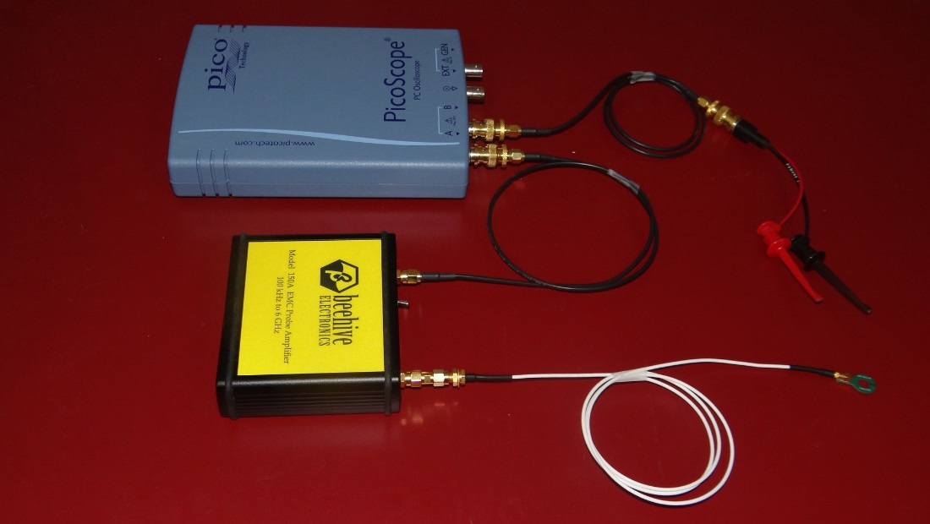

This diagram shows the connection layout attached to a micro controller ready for use:

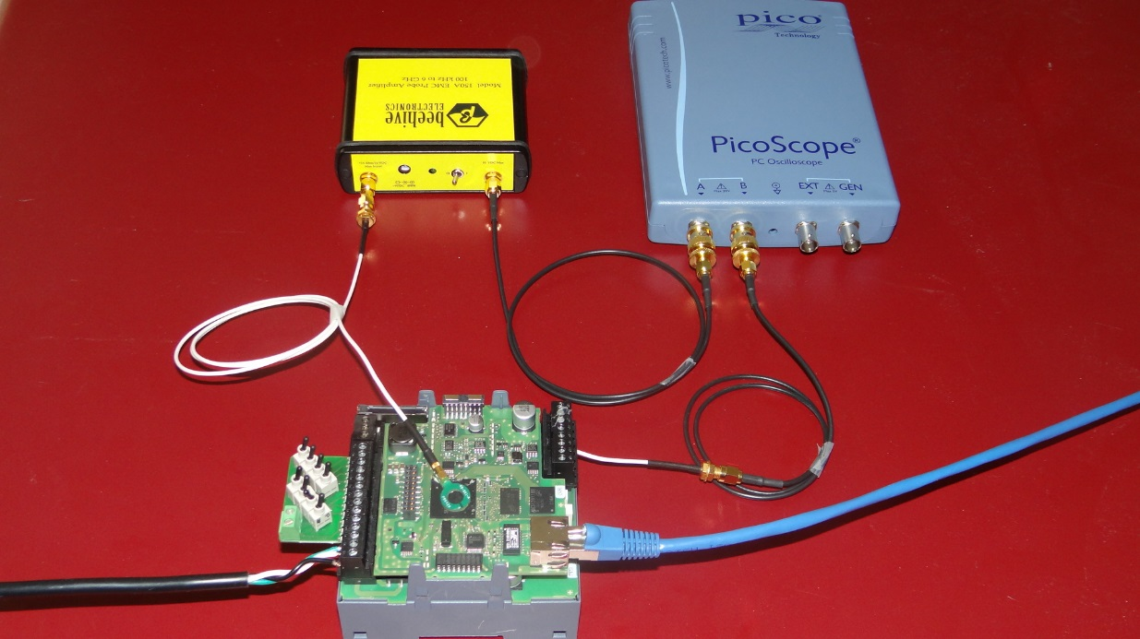

To run the Logger.

1. Unzip the contents of the PFPPicoLogger.zip
2. Open MATLAB.
3. In MATLAB, navigate to the directory where “PFPPicoLogger” was extracted.
4. At the MATLAB command prompt, type “Pico3406DLogger”, hit return. This should open the initial GUI.

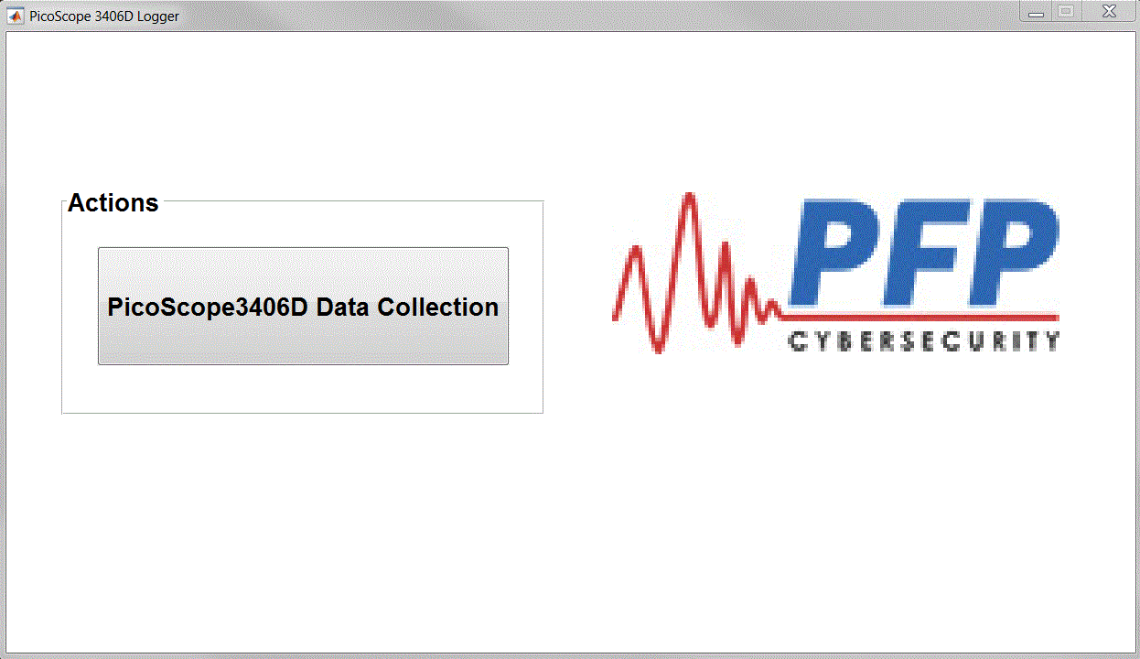

1. Click on the PicoScope3406D Data Collection button. This will prompted the user to navigate to a directory where the Configuration file is located. A default Configuration file (PicoScope3406DDAQconfig.json) is located in the Support directory.

The configuration file contains setting for the initial configuration parameters for the logger. Do not open the file to make changes, changes are made using the supplied GUI.

1. After the user selects the configuration file, the following GUI should be open.

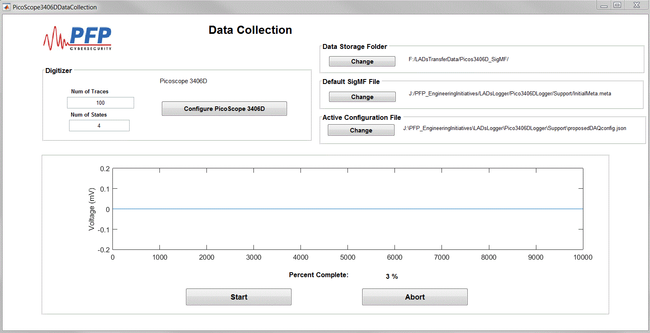

From the Data Collection GUI, the user can modify the defaults file options, modify Digitizer collection options, Configure the PicoScope 3406D or start the data collection process. It this is a new collection, it is advisable to first configure the PicoScope 3406D to ensure the PicoScope is configured correctly for the user’s application. To configure the PicoScope 3406D select the “Configure PicoScope 3406D” button. This will bring the user to the following GUI.

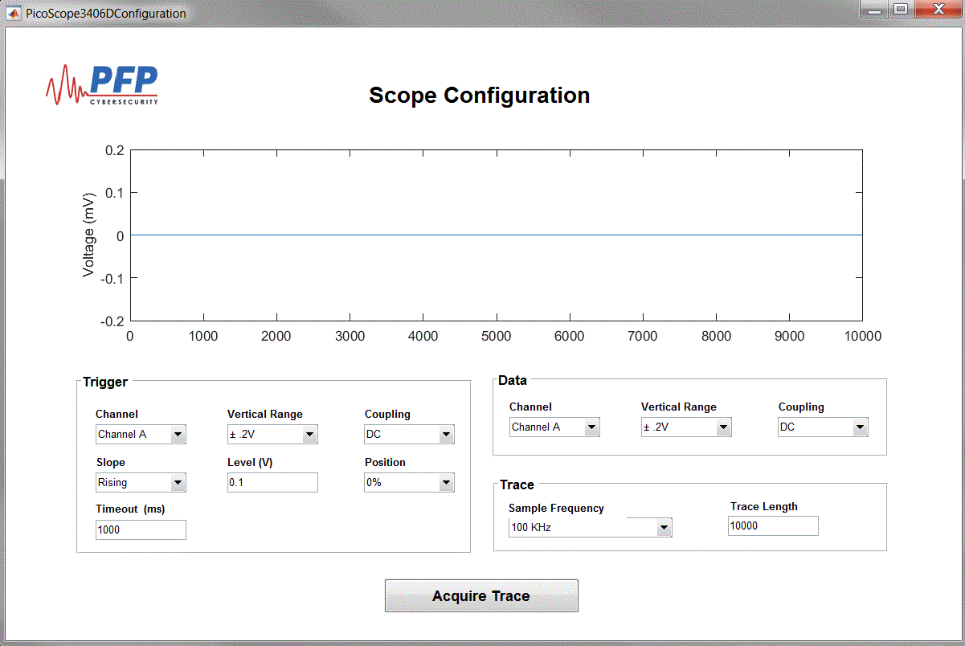

From this GUI the user can modify sampling parameters and observe the waveforms. Visually observing the waveforms can help ensure that PicoScope is correctly setup to the application. Once the sampling parameters a set, closing the GUI will prompt the user to either save the current settings or discard them and bring the user back to the Data Collection GUI.

Once the user is back at the Data Collection GUI and is satisfied with the Data Collection parameters they can initiate the data acquisition by selecting the Start button. The user will be prompted to that all data in the storage directory will be deleted.

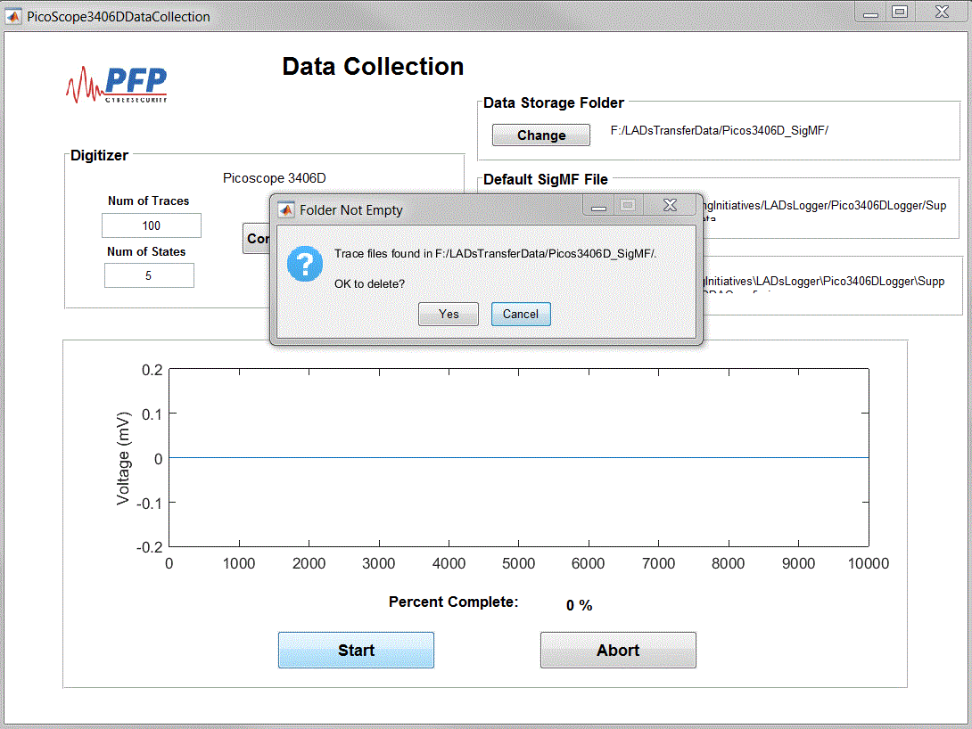

Next the user will be prompted to place the DUT in the desired State and continue with the data collection process.

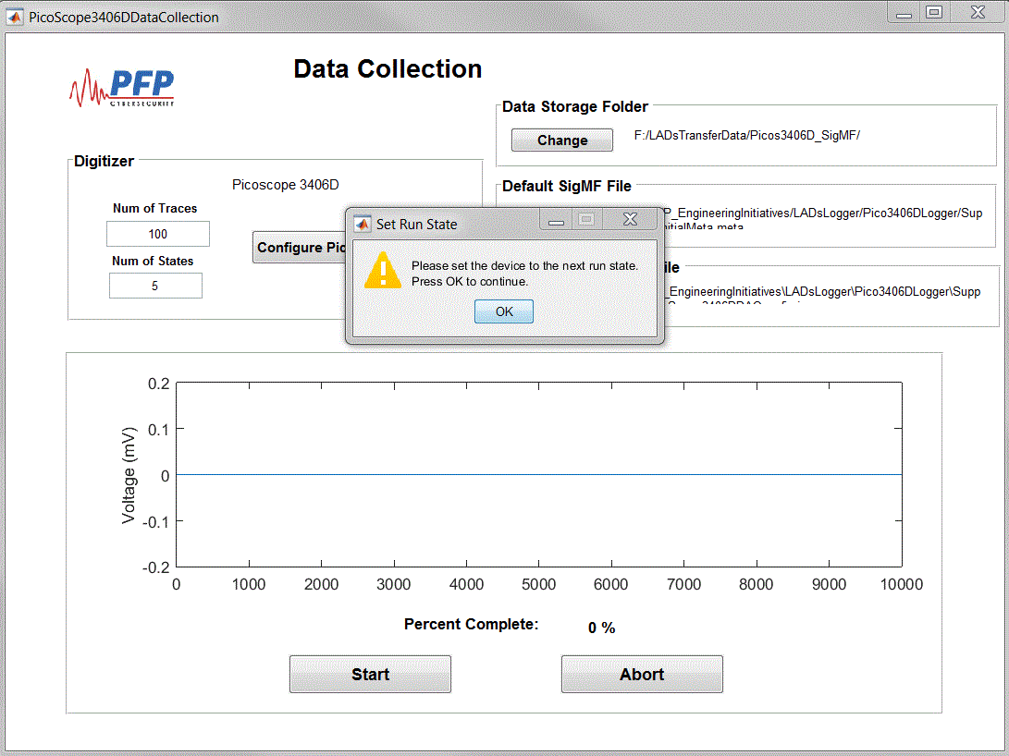

Once the data collection for the given State is completed the user will be prompted to change the DUT to the next State. After all State data is collected the will be prompted that the process is complete. The PFP Logger will write all the necessary files for analysis in the user specified directory.

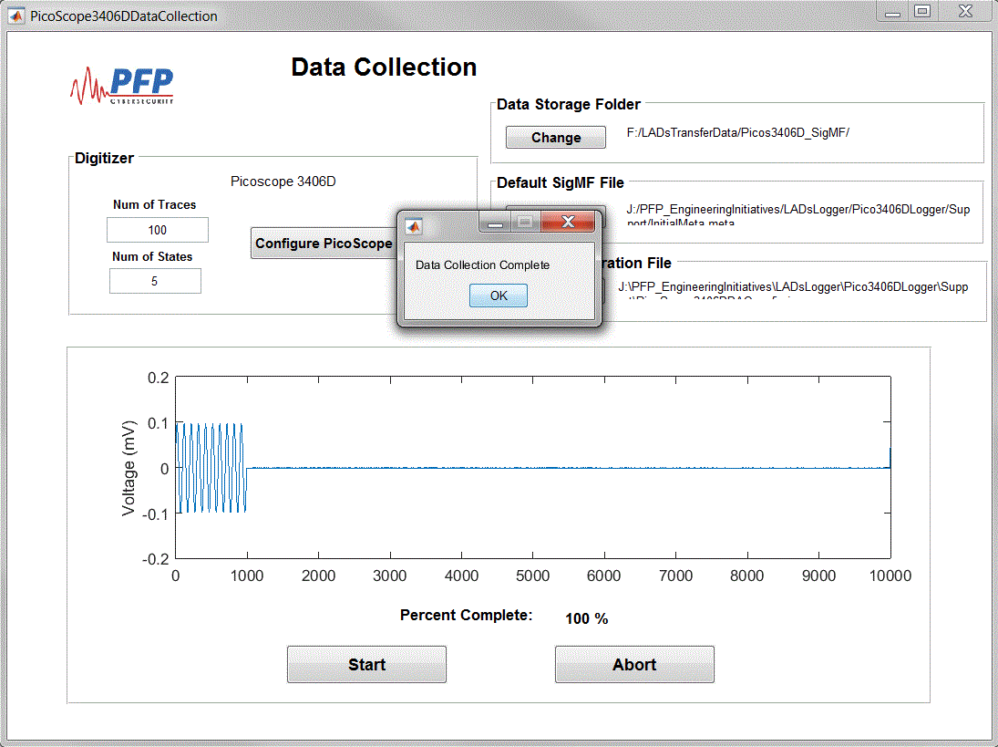

This is where we give instructions to upload the data. What do we want to put here??